This excel application is designed to take information from a database (Microsoft Database or Access Database) and display the requested data depending on the user’s choices through excel sheets and a Microsoft Word report.

Below is an overview of how to properly utilize the application:

The application is run through the “Display Control” tab in the ribbon using the given button in the “Grading” group shown below.

When running the application a user form will be brought up which prompts the user to select from a series of 4 options: “Import Data”, “Generate Report”, “List Courses”, and “Create Chart”.

Error validation is in place to safeguard against missing information but there is a recommended order in which to operate the application.

Firstly, select the “Import Data” option button and press the “Continue” button to bring up a user form which can browse to select the database file you wish to use in this application using the “Browse” button.

After selecting the desired database file the pathway will be stored in a textbox in this user form. Select the “Back To Main” button to return to the main user form. From the main user form select the “List Courses” option button to display the course listing user form.

Select a course option from the course listing, then press the “Load Data” button to load information from the database into the main excel application. This will create 2 new worksheets in the main excel application named “Student Data” and “Grade Data”.



The “Student Data” sheet contains all the student data (First Name, Last Name, StudentID) of the students taking the course selected and the “Grade Data” sheet contains all the grade data (StudentID, A1 mark, A2 mark, A3 mark, A4 mark, Midterm mark, Final Exam mark) for the selected course. Examples for each is shown below (Student Data on the left, Grade Data on the right)

Optionally, you can select the “Display Class Average” button either from the same user form or from the main one to display the average and standard deviation for each mark in the selected course.

From here, select the “Create Chart” option to be prompted for which assignment to create a chart of. Select one of the option buttons and press the “Create Chart” button to generate the chart.

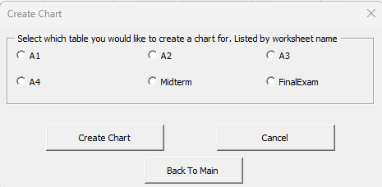

This will generate a new chart in the excel application named “Data Chart” which will contain all the data from the “Grade Data” worksheet.

Return to the main user form using the “Back to Main” button and select the “Generate Report” option button and press “Continue” to generate the Microsoft Word document with the chart and a brief explanation of what is displayed by the chart.